**GSA Agile Project – Wireframes**

These wireframes were developed to provide some initial guidance to the development team on the general look and feel of the application.

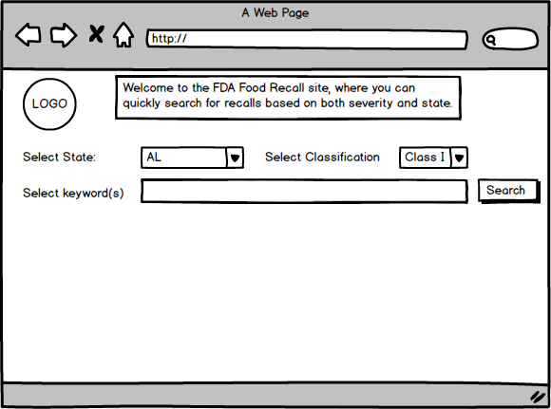

* User to select State
* State should have drop down of all 50 states
* User to select Classification – optional
* Classification should have drop down of Class I; Class II; Class III
* User to Select keyword – for fuzzy search
* User to press ‘SEARCH’ to initiate search
* No result should display appropriate message

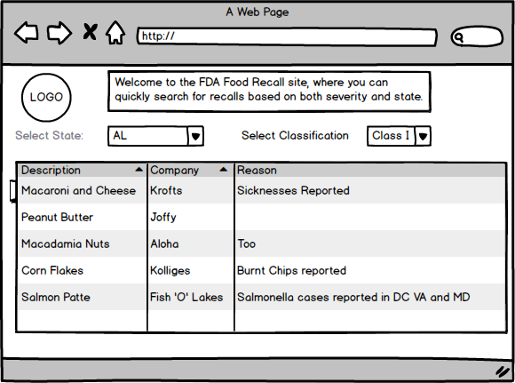

* Result set for search criteria displays
* Select columns display
* State and Classification displays
* No user entry
* User can select any item in the list to see further details

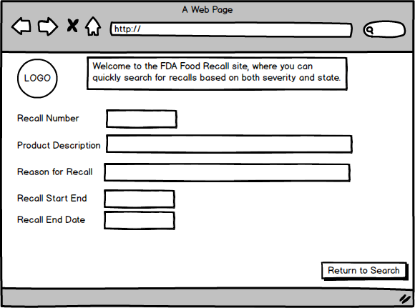

* Details display – final list to be determined
* All fields are display only – data cannot be changed
* User can return to Search criteria